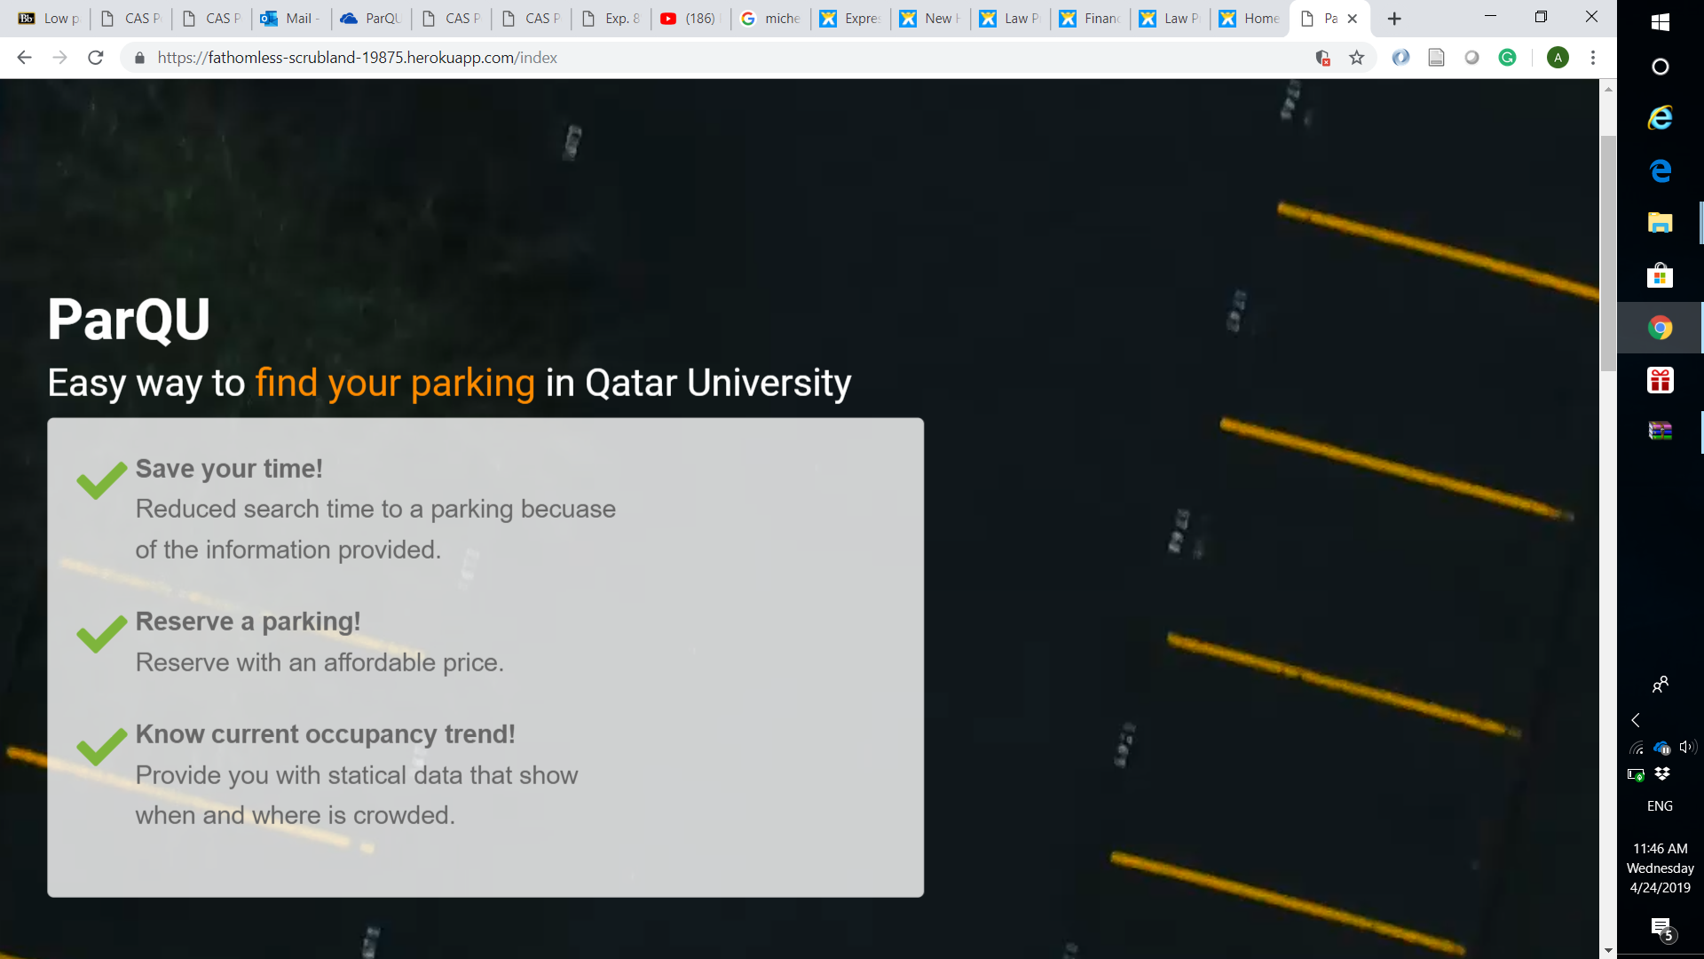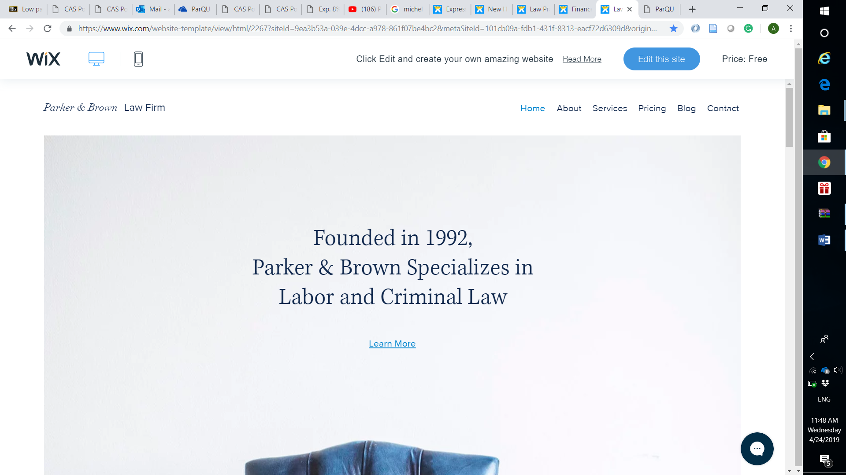

 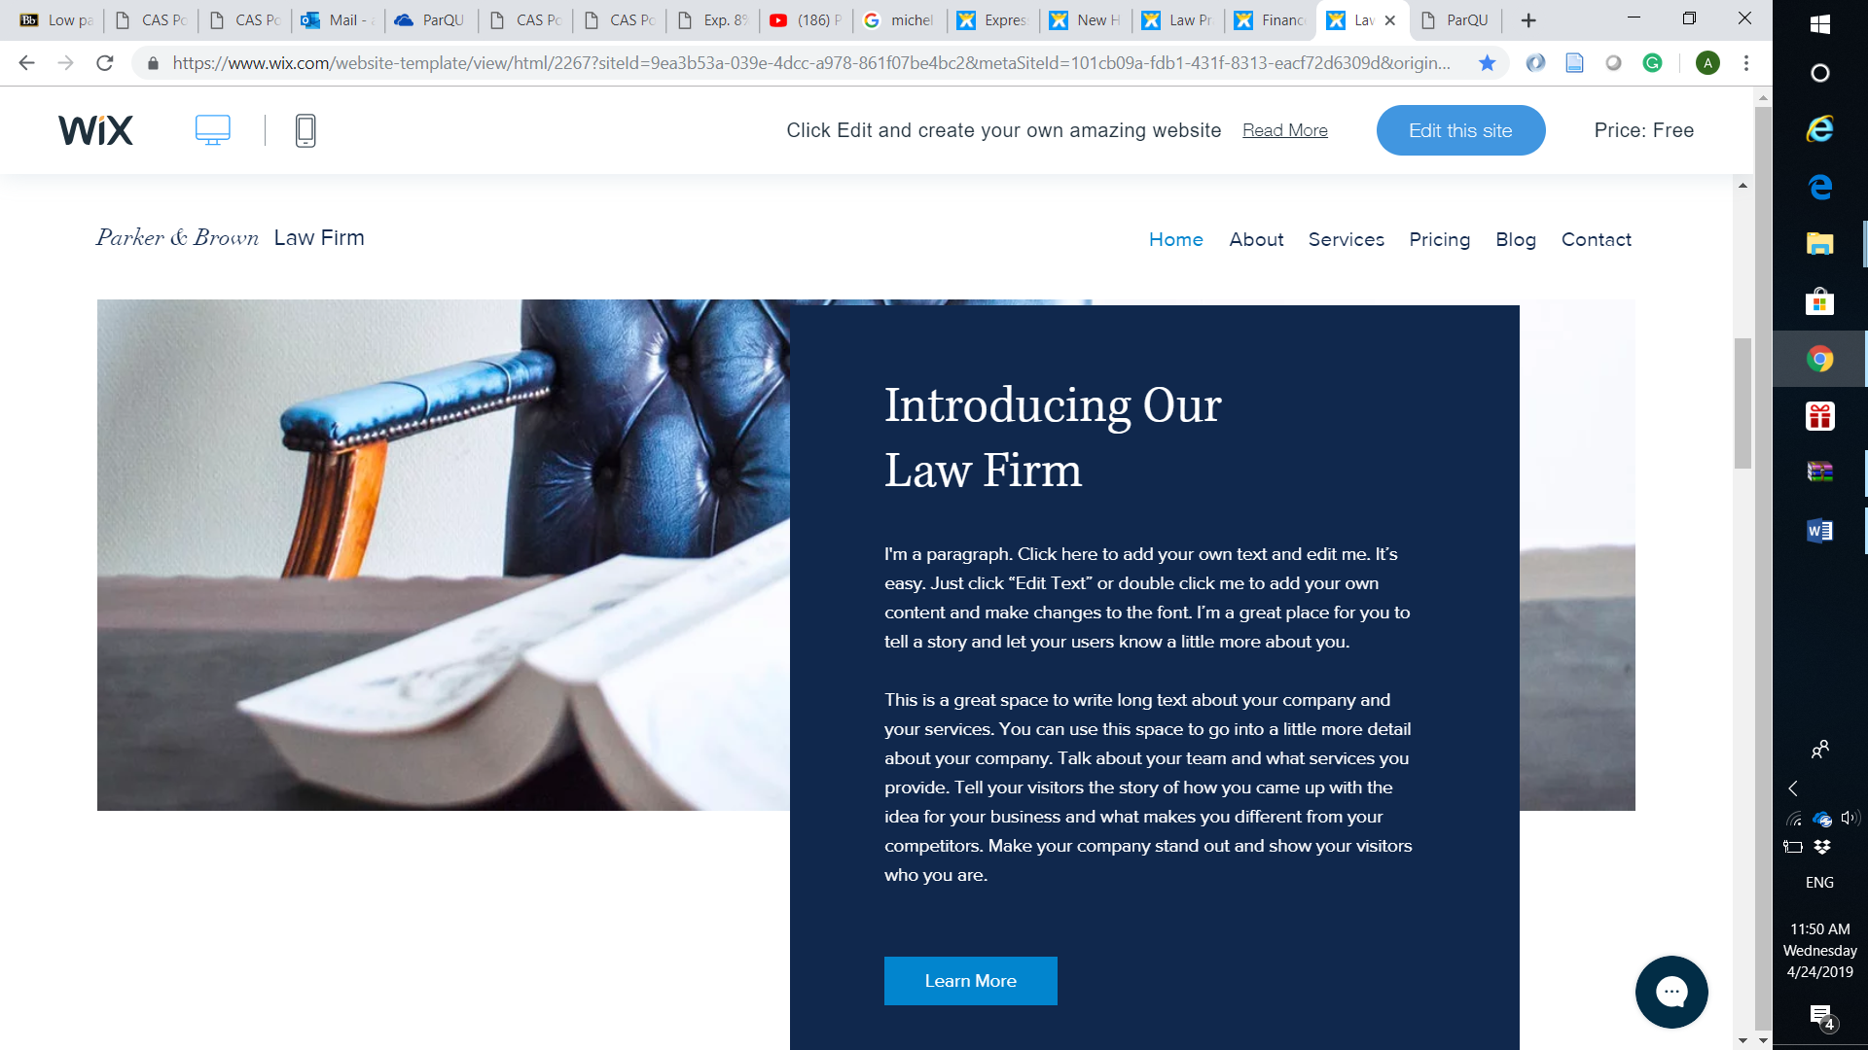

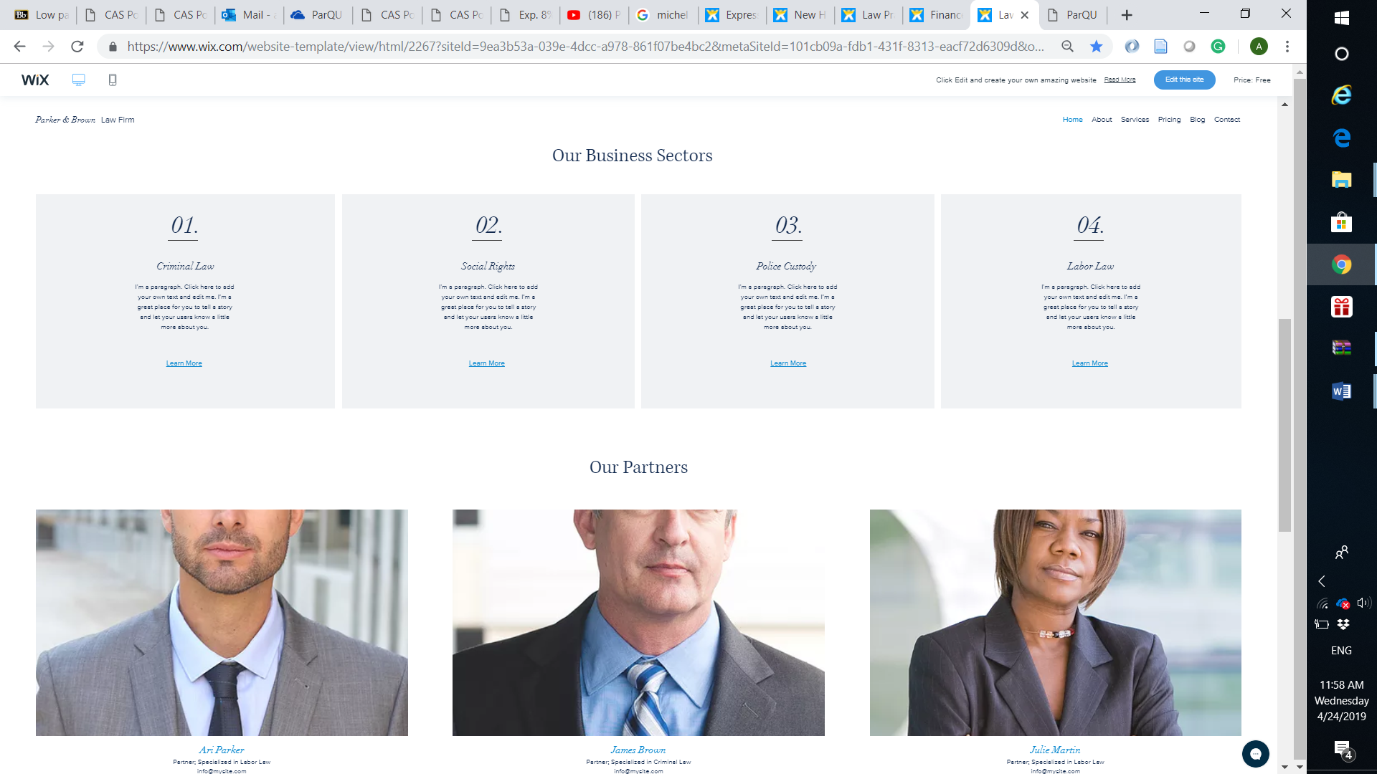

**Free Services**

**Show occupancy trend**

View the current trend in each zone for each day in the week.

**Currently Looking**

Show how many people are viewing a certain zone at the current moment.

**Check availability**

A map is displayed to you with a status shown for each parking spot. You can also get directions for a certain spot.

**Paid services**

**Request car care**

Go to Servesni mobile application or website.

Servesni provides several car care services such as: car wash,oil change and polishing

**Cancel a reservation**

50% refund per hour.

Cancel whole or part of the reservation.

**Extend a reservation**

1-hour extension.

5QR per extension

**Reservation**

5 QR per hour.

You can reserve starting from one day before the reserved time, and you can reserve up to 6 hours per day.

Triple price penalty for exceeding reserved time.

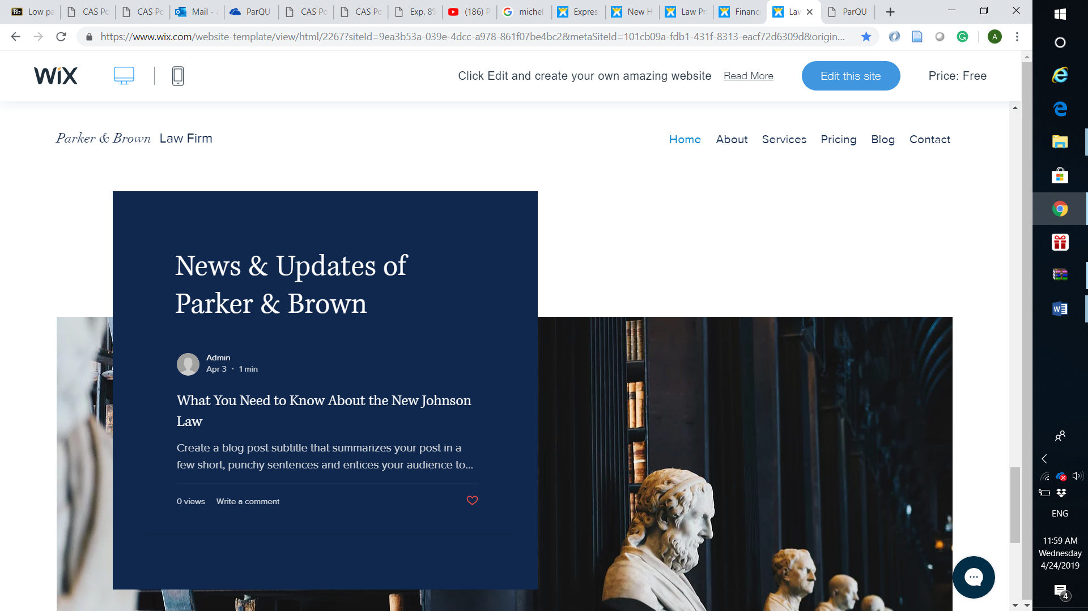

About ParQU

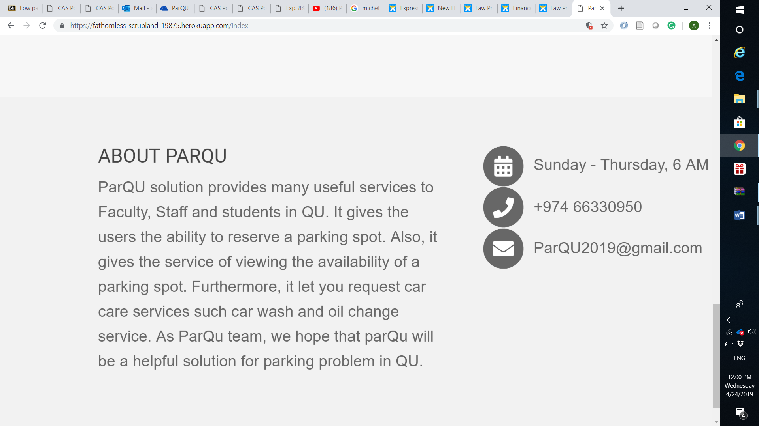

Contact us

If you have any question, concern or problem do not hesitate to contact us.

Please fill the form below and we will call you back shortly.

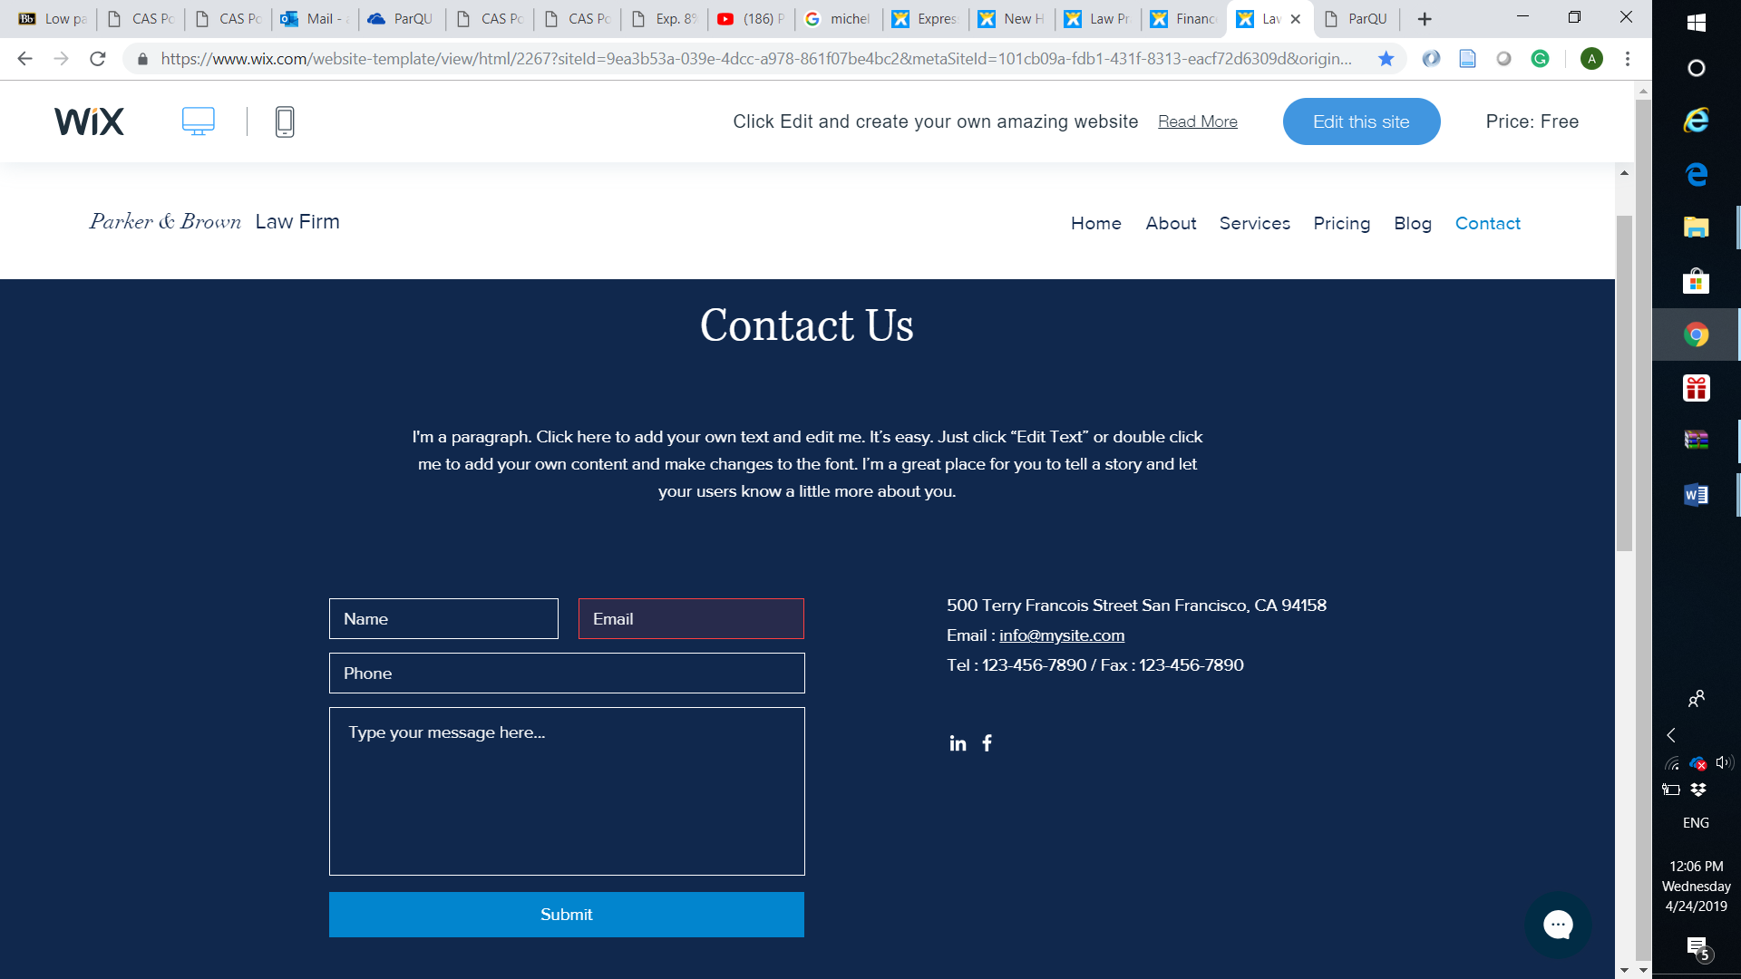

Learn more for each service should has small description + picture of mobile or website

|  |  |
| --- | --- |
| Free Services | |
| Service | **Description** |
| Check availability | One of ParQU’s main features is to give users the ability to view the status of current parking areas. This is done by displaying the parking area map with a status shown for each parking spot. We applied concept on 4 spots only. In addition, by using Google Maps, we are able to give users directions to the wanted parking spot from his/her current location (device location). |
| Currently Looking | It gives the users the ability to know how many people are viewing a certain zone at the current moment. |
| Show occupancy trend | The user views statistical data that represent occupied percentage in each hour for selected zone for last four weeks. |
| Paid Services | |
| Service | **Description** |
| Reserve a parking | Another main feature that ParQU provides to VIP users is the ability to reserve a parking spot for several hours. The VIP user is allowed to reserve 24 hours before the reservation time and can reserve up to 6 hours per day, for either a multiple or single reservation. The VIP user is charged with 5 QR per hour. Also, a VIP user is aided with a reminder about his/her current reservation expiry time. The application/website notifies the VIP user 30 minutes before expiry time. |
| Extend a reservation | The VIP user can extend his current reservation by one hour at the last hour of his/her reservation only when there are available parking spots in the next hour. Additionally, the VIP user can extend (one hour per extension) as many times as he desires if the above conditions hold. The VIP user will be charged 5 QR per extension and the extended hours will not be part of the allowable reservation time (6 hours per day). This is because a VIP user may need more than 6 hours, so we allow the user to extend as much as he wants but only if there are available parking spots. |
| Cancel a reservation | Cancel whole reservation:  A VIP user can cancel a reservation with 50% of the reservation price refunded. The reservation can be cancelled at the time when the reservation is made till the reservation start time  Cancel part of the reservation:  A VIP user can cancel part of the reservation (i.e. after the reservation has started). Moreover, 50% of the price of each cancelled hour is refunded to the VIP user  Automatic cancellation:  A VIP user can cancel his/her reservation without needing to cancel through an application or website. This is done when the VIP user checks out of his reservation by at least one hour before the reservation ends. |
| Request car care | The VIP user is redirected to the Servesni application that provides various car care services. |